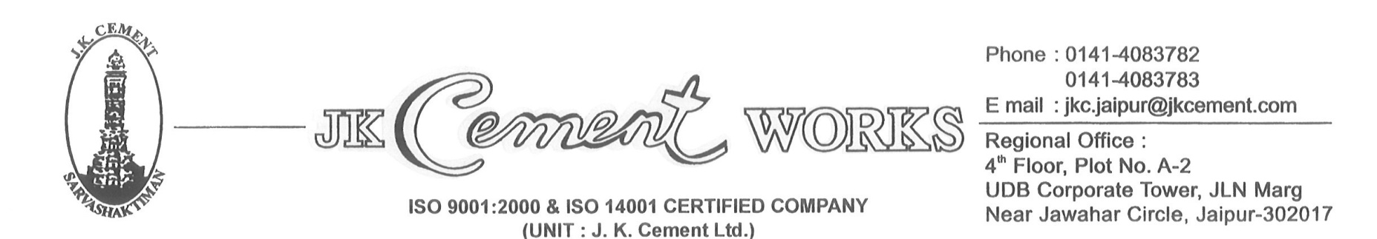

CIN: L17229UP1994PLC017199

Dear Stockiest, Date:-17.04.2021

You are aware that w.e.f. 01.07.2017, one of the global business decision was implemented in indirect taxation and GOI has decided for simple, rational and a unified indirect tax structure across the Country. The major change impacts not only the taxability but also the system and processes which we need to follow.

Our Cement in GST, falls in the category of 28%. Since the tax is unified combing the VAT, Excise duty etc. we will be billing you at basic price and applicable GST.

Under the GST regime, you will be able to take input credit, only if you are registered. Please get registered, if you have not taken registration so far and inform your registration number (GSTIN) at the earliest.

You are aware on announced schemes of sale discounts such as Cash Discount, quantity discount etc. along with the period of applicability. Additions/deletions of any existing discounts scheme or new discount scheme shall be informed personally in writing. The Company shall reverse the GST on said discounts while issuing credit note and you need to reverse your input tax credit to the same extent.

‘If J K Cement Ltd incurs, any financial liability due to non-reversal of the GST amount in your return the same will be recovered from you.’

Further to facilitate faster filing of return, it is beneficial to make the payment on invoice to invoice basis, and will reduce the complications with GST Authorities. Sooner or later Government will treat the GST portal like income tax portal where all claims of TDS are being settled through portal only.

If you need any clarification on the procedures, you may please get in touch with our Regional Marketing/Accounts Office, who will always be there to assist to give clarity on GST issue.

Thanking you,

For J K Cement Ltd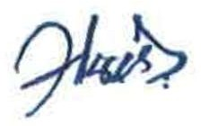

Regional Manager- Marketing

